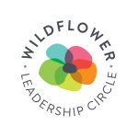
The Leadership Circle is a giving society comprised of Wildflower’s most generous donors -- those who contribute $1,000 or more each year. Members play an important role in Wildflower’s growth, enabling us to both expand the services we offer, as well as increase the number of families we support. Your generosity directly impacts the lives of Wildflower children and families. You become a part of their journey as they strive to rebuild after the devastating loss of a parent.

According to Executive Director Audrey Loria, the Leadership Circle is “an opportunity for donors to feel a strong connection to our families, as well as deepen their understanding of Wildflower’s mission.” Donors may give as an individual or company. Donations may be designated in memory of, or to honor, a loved one.
Wildflower’s unique approach is specifically tailored to each of our families who have all experienced the trauma of parental loss. By pairing each family with a dedicated family liaison, we are able to establish deep relationships with our families, enabling us to support them with programming that speaks directly to their needs. Leadership Circle members are included in this journey through story sharing and program updates.
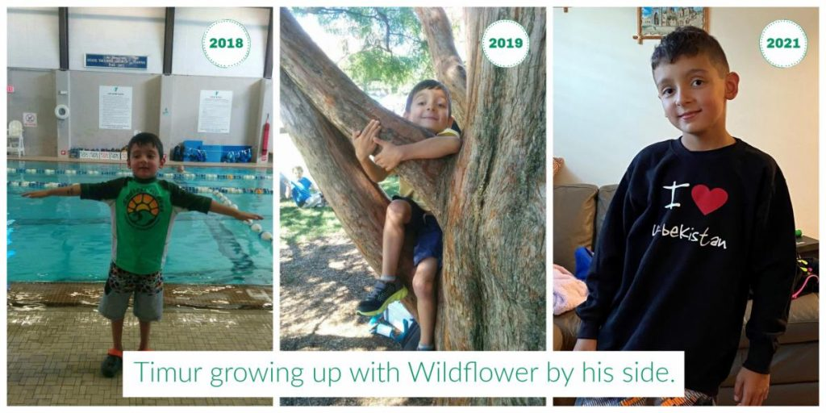
Leadership Circle members will enjoy a close relationship with our organization, receiving special updates about our families and program. You will be publicly recognized (if desired) as a member of our most generous donor group. And, you will receive special invitations to donor recognition events to celebrate your support.
Generous donors like you enable Wildflower to continue our important work. Our combined efforts give hope to families who have experienced the anguish of losing a parent. We welcome your participation in the Leadership Circle. Together, we will make a difference in the lives of children and families living with grief.
For more information, please call 781-861-1413 or info@wildflowerforkids.org. Or donate now and receive a welcome call from us.

