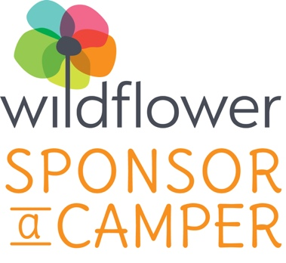
A Meaningful Donor Experience
The Sponsor-a-Camper donor program matches donors to Wildflower campers. It is a meaningful and impactful donor experience.
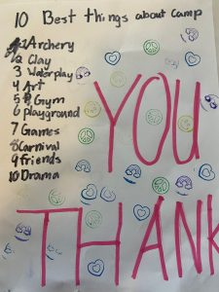
With an annual gift of $2,500, sponsors are carefully matched to a Wildflower camper who is in need of our unique blend of services. Your donation funds their summer camp experiences, and sparks a link between you and the camper as they share stories with you about summer camp. This is a truly meaningful giving opportunity offering a firsthand account of the impact of your generosity.
Membership carries the satisfaction of knowing that you are directly affecting the life of a child living with grief. Sponsors receive a profile of your child’s background, as well as an end-of-summer update each year about your camper and family. Plus, all Sponsor-a-Camper donors automatically become members of the Leadership Circle, Wildflower’s insider giving club. Learn more about the benefits of membership here.
With continuous support, summer after summer, Wildflower’s program helps children rediscover life after loss through the engaging experience of camp. The camp experience also provides a welcome respite for the surviving parent, giving them an opportunity to rest and restore. In turn, parents are able to create a stable environment at home. Sponsors are key contributors to this healing journey.

Just as the camper and family benefit from this program, the sponsoring family does, too. Wellesley residents Scott and Elaine Ravelson share their experiences as Wildflower’s first Sponsor-A-Camper donors. “Being a part of this program has been a powerful experience, knowing that our contributions are making a real difference for a local family.”
The number of children requesting support from Wildflower continues to grow. In order to meet the demand, we need your help. Please join us as Sponsor-A-Camper donors to ensure that every child seeking support has the opportunity to receive the gift of camp. We hope that you will be a part of our mission to create a world where all children and families who experience the death of a parent receive the support they need to recover and to thrive.
For more information about Wildflower’s Sponsor-A-Camper program, please call 781-861-1413 or email us at info@wildflowerforkids.org. Or, make your donation today and Wildflower will be in touch to begin matching you to a Wildflower family.

