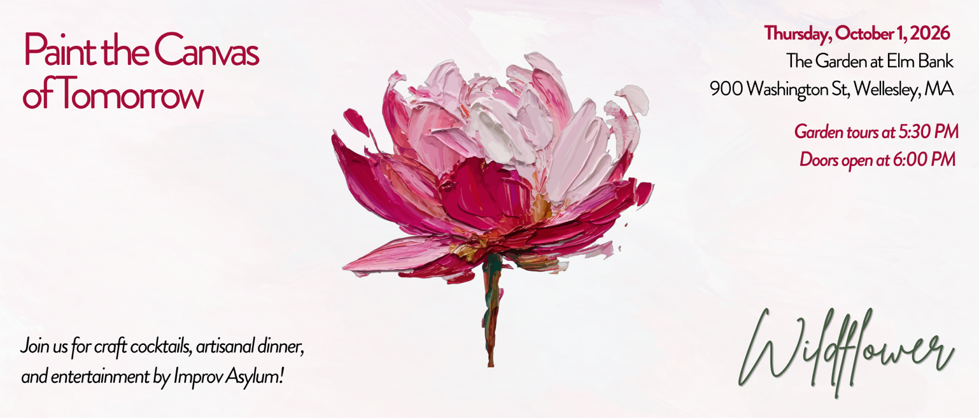
Sponsorship Opportunities
Inspired by vivid visuals of spectacular camp summers, Paint the Canvas of Tomorrow honors the color and light that Wildflower brings to grieving families. Sponsorship of this event directly funds camp scholarships, family programming, and the next chapter of this community while carrying forward twenty years of trusted care.
We will celebrate and welcome our new leadership as they pick up the brush, ready to build the future of Wildflower. The evening's improv entertainment will reflect that same energy — light, engaging, and full of possibility. When guests arrive, they may stroll through the magnificent gardens at Elm Bank Reservation. A cocktail reception, dinner by Tastings Catering, and event program will follow. We will cap off the night with a comedy performance by Improv Asylum. Don’t miss this rare opportunity to align your brand or offer sustaining support.
Level | Investment | Recognition & Benefits
Masterpiece Sponsor | $7,500 | Supports three children to attend one full season of camp  Presenting Sponsor: Logo/name highlighted on event signage and in virtual program; verbal recognition at event; complimentary attendance for 8 guests; priority shoutout on event website and social media
Gallery Sponsor | $5,000 | Supports two children to attend one full season of camp  Logo/name featured on event signage and in the virtual program; verbal recognition at event; complimentary attendance for 6 guests; logo recognition on event website and social media
Studio Sponsor | $2,500 | Supports one child to attend one full season of camp  Name/logo featured on event signage and listed in the virtual program; complimentary attendance for 4 guests; recognition on social media
Palette Sponsor | $1,000 | Helps provide camp scholarships for bereaved children  Name/logo featured in the virtual program; complimentary attendance for 2 guests; recognition on social media

Wildflower is dedicated to serving families with children across Greater Boston who are grieving the devastating loss of a parent. By facilitating rejuvenating summer programs, Family Liaison support, and long-term wraparound care, Wildflower accompanies families on their bereavement journey as they rediscover life after loss. Wildflower has facilitated over $4.5 million in camp scholarships over its 20+ year history — and your sponsorship will help carry that legacy forward.
See sponsorship levels above. In-kind donations (e.g. raffle items, printing, and event materials) are also welcome and will be recognized. For further questions on sponsorships or in-kind donations, please contact Diane Gardner at dgardner@wildflowerforkids.org.

If you would like to register as a sponsor at any level, fill out the following form and mail with a check to 117 Kendrick Street, Suite 300, Needham, MA 02494. If you would like to make your donation via credit/debit card or DAF, please complete your registration via our Google Form.

Sponsorship Commitment
Name / Company
Contact Email & Phone
Address
Sponsorship Level
Amount Enclosed
Payment Method
(Cash, Check, DAF)
Signature / Date
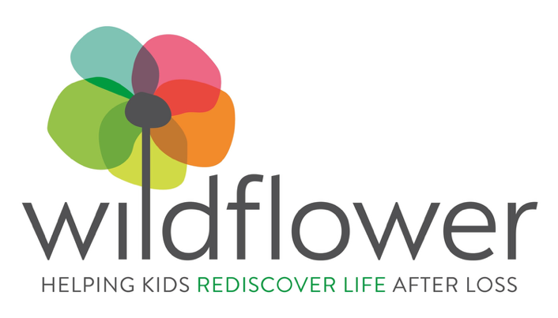
Wildflower is a 501(c)(3) nonprofit organization; sponsorships are tax-deductible to the extent allowed by law.

